CODE QUALITY – LAB 10

EC 5080 – SOFTWARE CONSTRUCTION

WIJAYAWARDHANA W.A.H.A.

2019/E/166

SEMESTER 05

09 NOVEMBER 2022

TASK 01

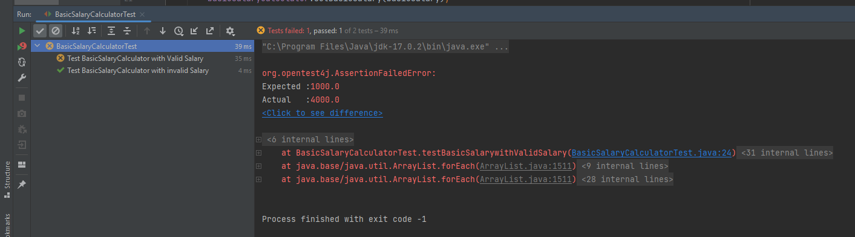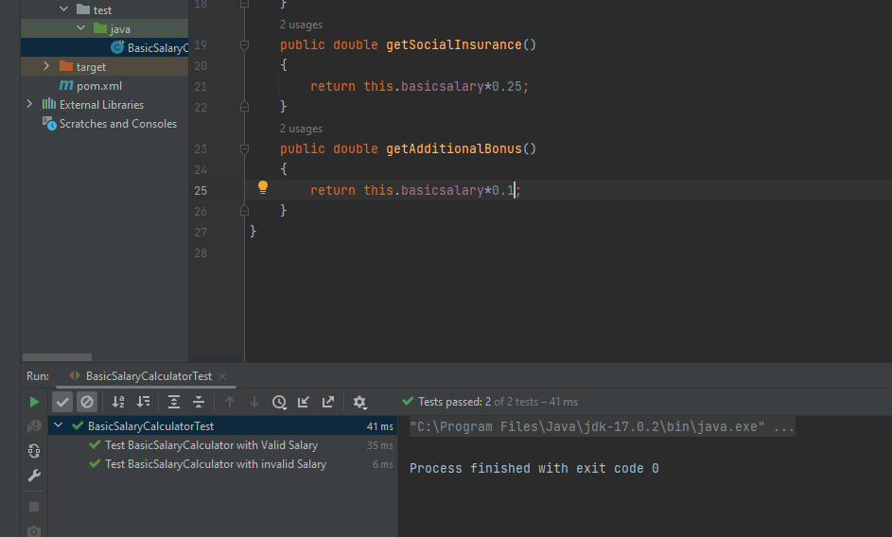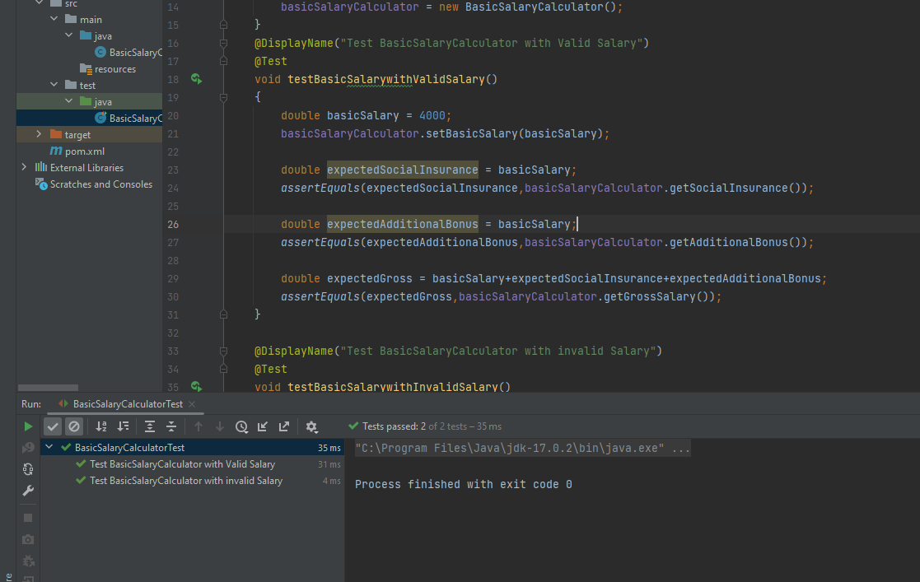

TASK 02

|  |  |  |
| --- | --- | --- |
| Lab Number | Test case  (description/equation/java  statement) | Expected Output |
| 01 | evaluate: 3 + 8 | 11 |
| 02 | String[] stringArray = {"alpha","gamma","beta","delta"};  BS(stringArray); print(stringArray);  FindDuplicateElements | alpha beta delta gamma  [11,34,3] |
| 03 | Accounts(10000,1234567)  getBalance()  getAccountNumber() | 10000  1234567 |
| 04 | getAllOutgoingRoads() | city1->city4->city3 |
| 05 |  |  |
| 06 | findArguments(“generic quit”) | (“gheneric”,”quit”) |
| 07 |  |  |
| 08 | setName(“Kamal”)  getName()  setRegNo(”2019/E/166”)  getRegNo() | ”Kamal”  “2019/E/166” |
| 09 | clientMessage = “bye” | Exit |

TASK 04

